Mrs. Eller’s Kindergarten
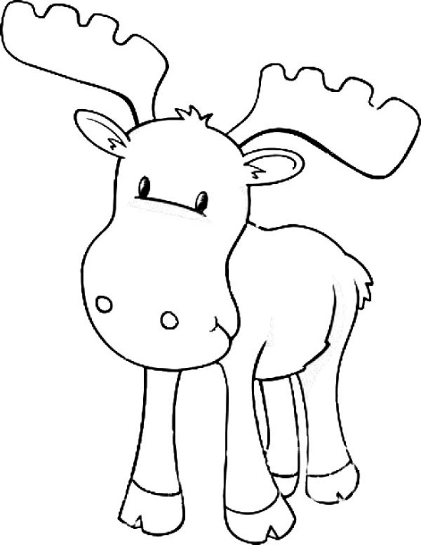
November Newsletter
November Themes:
Scarecrows and Crows
Election and Veteran’s Day
Turkeys and Thanksgiving
Important Dates:
7th- Electives Begin
7th - Report Cards
8th - 2 Hour Delay, School begins at 11:15am
10th- Student Led Conferences, 3:00-3:30pm
11th - NO SCHOOL (Holiday - Veterans Day)
14th-18th - Book Fair
17th - Curriculum Night, 5:30-8:00pm
18th - Lowes Foods Field Trip
23rd-25th - Thanksgiving Break
Book Fair: We will preview the books on and your child will bring home a list of books that sparked their interest. If you would like to purchase books for your child, please send money in a sealed envelope marked with their name. Our class will visit the book fair to purchase books on TBD.
Electives: begin on November 7th. We are super excited about our new adventures in learning. Be sure to ask your child all about their elective.
Report Cards: will be sent home in today’s Monday folder (Nov. 7th).
Student Led Conferences: will be held Thursday, November 10th from 3:00-3:30pm. Your student will need to have one person present to discuss their digital learning portfolio (Seesaw). If a parent is not able to come, you may send a grandparent, older sibling, or someone so that your student can share their accomplishments and set learning goals.
November Math: Understanding the relationship between numbers and quantities: counting to 100 by ones and tens, counting forward from a given number in any sequence, writing numbers 1-20, counting 20 objects in a line, rectangular array, scattered, or circle, identifying greater than, less than and equal, comparing written numbers 1-10, addition and subtraction stories, attributes: shape, size and color. Reading and writing number words one-twenty. Composing and decomposing numbers 11-19: teen, ten groups, partners of numbers, composing and decomposing with objects, drawings and equations.
November Reading: Using Reading Strategies (Tricks & Tools for Reading): Crosscheck-Does it look right? Does it sound right? Does it make sense? Use tools/strategies to make meaning when reading. Using letters and sounds to read and build words. Using syllables, phonemes, beginning sounds, rhymes, phonics, decoding, word analysis skills, high frequency words to read. Asking and answering key questions in a text. Asking and answering questions about unknown words in a text.
November Writing: Writing like scientists by observing the world around. Including observations of size, color, shapes, texture, and number in writing. Writing a story in sequence, beginning, middle and ending. High Frequency Words for November: on, no, not, was, with, me, my, you, said

