Annie Apple

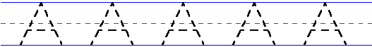
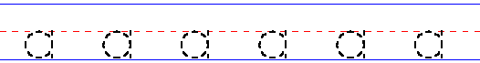

Bouncy Ben

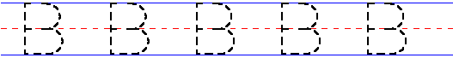

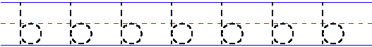

Clever Cat

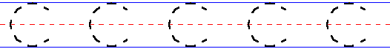

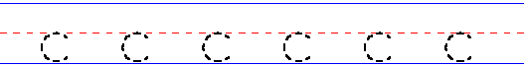

Dippy Duck

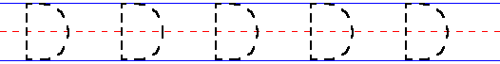
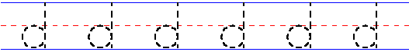

Eddy Elephant

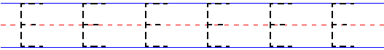
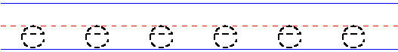

Firefighter Fred
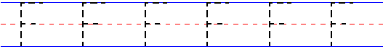

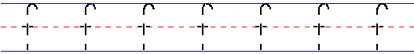

Golden Girl
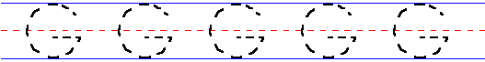
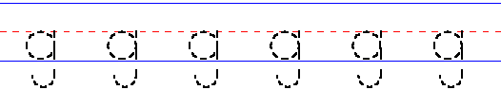

Harry Hat Man

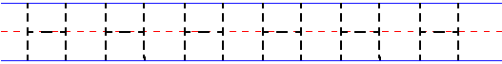
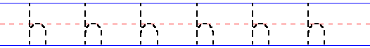

Impy Ink

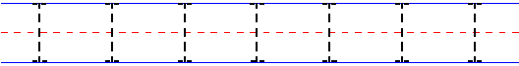
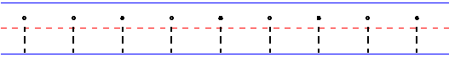

Jumping Jim
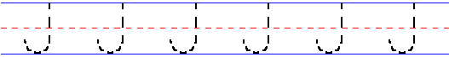
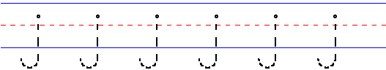

Kicking King

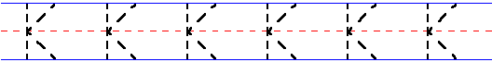
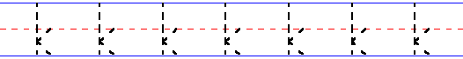

Lucy Lamp Light
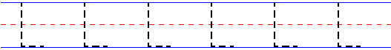
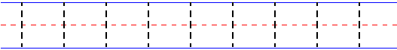

Munching Mike

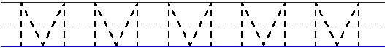
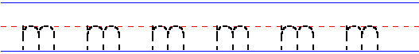

Noisy Nick

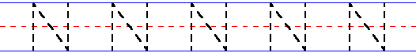
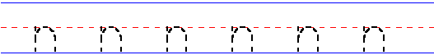

Oscar Orange

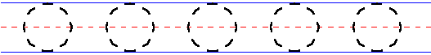
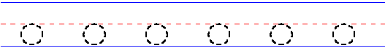

Peter Puppy

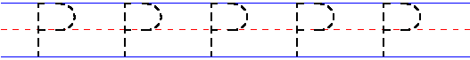

Quarrelsome Queen

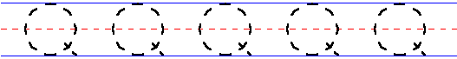
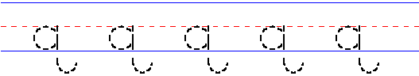
Red Robot
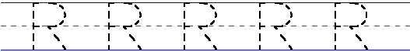

Sammy Snake

Talking Tess

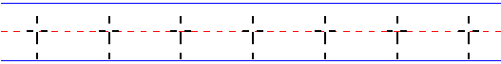

Uppy Umbrella

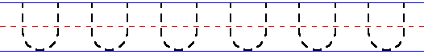

Vicky Violet

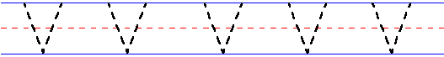
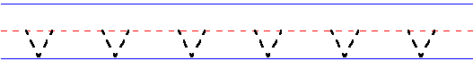

Walter Walrus

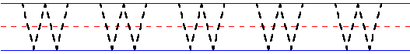
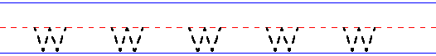

Fix-it Max
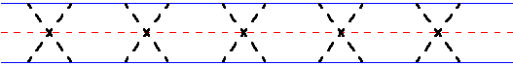
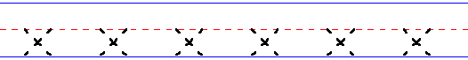

Yo-yo Man
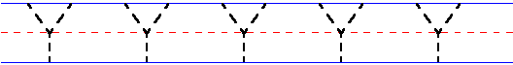
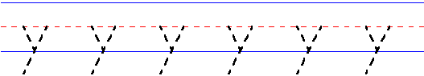

Zig Zag Zebra

