Mrs. Eller and Mrs. Hines’ January Kindergarten Newsletter

Important January Dates:
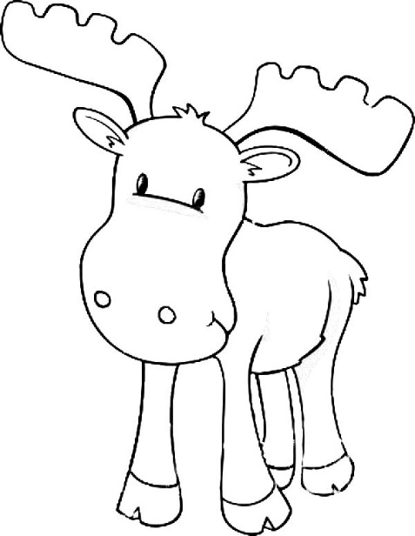
2nd - NO SCHOOL (Holiday)
6th - Elective Forms Due
12th - Q2 Electives End
13th - Marbles Field Trip
16th - NO SCHOOL (Holiday)
20th - Early Release (Dismissal at 1:15pm)
23rd - Q3 Electives Begin
24th - End of Q2
27th - NO SCHOOL (Teacher Workday)

January Themes:
Resolutions & Snow
Mittens & Cocoa
Arctic Animals
Classroom Needs: small cotton balls, INK!! HP 564 (black and color), extra emergency snacks
​Elective Registration: Elective registration sheets will be sent home in Monday folders. Please complete and return forms by Friday, January 6th. You are submitting your selections for the remainder of the year. Your child will register for TWO electives for 3rd Quarter and TWO electives for 4th Quarter. Please be sure to complete all choices as classes fill up quickly. (We often need to go down the list to meet the interests of your child). Elective changes should be sent directly to Mrs. Johnson at jjohnson6@wcpss.net by January 20th. Electives for 3rd Quarter begin on Monday, January 23rd. Since we will have two electives, we will have specials less often, about twice a week.
Chaperones Needed: If you have been approved as a chaperone by WCPSS you are welcome to meet us at Marbles Museum for our field trip on Friday, January 13th. We are in need of several chaperones to guide a small group about the museum. We will be arriving 10am and departing at 12noon (times are approximate). Please email me if you can help! Chaperones will need to provide their own transportation and pay entrances fees upon arrival.
Hunter Magnet Tours will be held on Wednesdays in January. Be sure to spread the news to any prospective parents. We’d love to welcome new families to our Hunter Community.
Assessments:
County wide benchmark assessments and mid-year assessments will be given in January. Your child will be assessed for both literacy and math. In literacy, your child will be assessed on: Letter Identification, (upper and lowercase), Letter Sounds, (upper and lowercase), First Sound Fluency (FSF), when told a word, they are asked to segment the beginning sound (cat “c” sound), Letter Name Fluency (LNF) when shown a list of letters, they are asked to tell the letter name, Phoneme Segmentation Fluency (PSF) when told a word, they are asked to break apart the sounds in the word, Nonsense Word Fluency (NWF) when shown a nonsense word (such as vec, tun), they will be asked to read the word, Reading Level (TRC) and comprehension (characters, setting, making connections, providing supporting evidence in the text etc.), High Frequency (Word Wall) Words
In math, your child will be assessed on: number identification (0-100), counting to 100 by 1s, and10s, subitizing, counting objects in an array, line and scattered, teen number, counting on from 10, identify the missing number (5, ___, 7), quantity discrimination: more/less (7, 9), count forward from any given number, writing numbers 1-20, positional words (such as above, below, beside, in front of, behind, and next to), identifying shapes regardless of orientation or size (square, rectangle, oval, circle, triangle, hexagon, cone, sphere, cylinder, cube), describing and comparing attributes of shapes (vertices, sides, faces, corners, angles) of 2-D(flat) and 3-D shapes (solids), building and drawing shapes.
To help your child at home, be sure to visit the resources tabs on our class website.
​Career Volunteers Needed: Do you have an interesting, fun, unique career that you’d like to share with our Kindergarten students? We are in need of volunteers to share during Career Week (last week this month). If you can help, please email me and let me know what you’d like to share.
January Math:
count to 100 by 1s and 10s, count forward from any given number, describe objects in the environment, using the names of shapes and describe relative position in terms (such as above, below, beside, in front of, behind, next to), name shapes regardless of orientation or size, identify 2-D (flat) and 3-D (solid) shapes, compare 2-D and 3-D shapes to describe similarities, differences, part, attributes, (vertices, corners, sides, length etc.), build and draw shapes, compose simple shapes to form larger shapes (such as combining two triangles to form a rectangle)
January Literacy:
Reading Unit 5: Partners Help Teach Each Other to Read
We will read texts with confidence and use the strategies to tackle unfamiliar words and understand the text. We will review and practice how to talk with a partner making several back and forth exchanges speaking in complete sentences and using phrasing and wordage that is taught. We will begin to see how authors carefully choose interesting words to describe (verbs) what characters are doing and how knowing this will help with understanding. We will ask questions so we can understand what are reading and help partners. We will use decoding strategies to figure out unknown words. We will look for familiar sight words in books. We will use evidence from the story to support our responses. We will share the main idea of the books and give events/ key details from the story to support our answers. We will learn how authors carefully choose interesting words to describe characters.
Writing:
Procedural Writing - How Tos
Writing explanatory/informative texts that name what they are writing about and supply information, steps involved in How To. For example, How To Build a Snowman (First, Next, Then , Last).
Word Wall: Students are expected to be able to read and spell all the words we have learned and added to our “Word Wall”. We practice these words daily during meeting time. Be sure to practice at home too. We will have a ‘quiz’ on spelling these words each month. Word Wall (High Frequency) Words we have learned: a, an, as, all, at, and, can, go, I, in is, it, look, like, me, my, no, not, on, see, the, to, you, he, him, his, she, her, big, little, up, down. See High Frequency List on our website for a complete list. The goal is over 50 words by the end of the year.

