Mrs. Eller and Mrs. Hines’ February Kindergarten Newsletter
Upcoming Events:
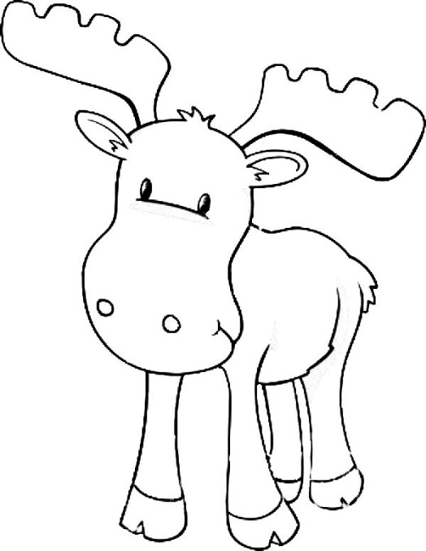
3rd - 100th Day Projects Due
8th – Parent-Teacher Conferences (please note your scheduled time in your confirmation email)
9th - 100 Days Smarter Celebration Day!
10th - Early Release (Dismissal at 1:15pm)
16th - PTA Skate Night at United Skates, 6-8pm
17th - National Digital Learning Day
20th - Snow Makeup Day (regular school day)
24th – Dance IN
February Themes:
100th Day of School
Valentines & Sweetness
Dragons (Chinese New Year) & Teeth
Classroom Needs: white cardstock, snacks!, 2 bags of each: Hersey’s Hugs and Kisses, candy/gummy hearts for math
Report cards: were sent home in today’s Monday folder. Please sign and return the envelope, the paper inside is for you to keep.
Valentines/Friendship: in an effort to promote healthy Hunter stars, we are requesting that if you send in a treat that you consider healthy choices (strawberries, fruit snacks, pretzels, etc.) Also, if your child would like to send in cards to friends, please be sure include a card for EVERYONE in our class. We have 24 students. You can find a list of friends in our class on our website. We are planning some educational activities (graphing, sorting, voting) with candy. If you would prefer for your child not to eat the candy, please let us know and we will provide them with another snack after the activity.
BYOD: We will continue to work out the kinks for BYOD. Your student is welcome to bring their device on Friday during the month of February.
Math
Positional Words & Shapes – Correctly name shapes regardless of their orientations or overall size. Model shapes in the world by building shapes from components (e.g., sticks and clay balls) and drawing shapes. Compose simple shapes to form larger shapes. For example, "Can you join these two triangles with full sides touching to make a rectangle?"
Addition and Subtraction Within 5 - Represent addition and subtraction with objects, fingers, mental images, drawings, sounds (e.g., claps), acting out situations, verbal explanations, expressions, or equations. Solve addition and subtraction word problems, and add and subtract within 10, e.g., by using objects or drawings to represent the problem. Decompose numbers less than or equal to 10 into pairs in more than one way, e.g., by using objects or drawings, and record each decomposition by a drawing or equation (e.g., 5 = 2 + 3 and 5 = 4 + 1). For any number from 1 to 9, find the number that makes 10 when added to the given number, e.g., by using objects or drawings, and record the answer with a drawing or equation. Fluently add and subtract within 5.
Literacy
Literacy Unit: Review and practice community partnership rules. Establish new partnerships. Careful readers get their minds ready to read before reading. Readers teach each other in partnerships. Readers reread, rather than abandon books. Readers share and celebrate the funny parts. Participation in collaborative conversations with diverse partners. With prompting and support, identify the main topic and retell key details of a text. Know and apply grade-level phonics and word analysis skills in decoding words. Demonstrate basic knowledge of one-to-one letter-sound correspondences by producing the primary or many of the most frequent sounds for each consonant. Read common high frequency words by sight – Please continue to work with your child on our High Frequency Word List. The words we have learned thus far are expected to be read and spelled correctly. Word Wall (High Frequency) Words we have learned: a, an, as, all, at, and, can, go, I, in is, it, look, like, me, my, no, not, on, see, the, to, you, he, him, his, she, her, big, little, up, down, was, with, said, come, some, here, be, by, so, do. This month we will add the words: if, of, are, for, have, has, had, will, were, what (See “reading resources” tab on class website for a list of the words to practice at home).
Reading Strategies we have learned: listen for interesting words, use the pictures, read good fit books, play with rhyming words, know letters and sounds, stretch or blend sounds in words, check for understanding, name the characters, setting, problem and solution, identify fiction, and nonfiction, retell the beginning, middle and end, identify beginning and ending sounds, connect to the story, chunk letters and sounds, name the author's purpose, making predictions, flip the sound (long/short vowels), practice sight words, and using punctuation.
Writing: How-To Writing
Use combination of drawing, dictating, and writing to compose informative/explanatory texts in which they name what they are writing about and supply some information about the topic. Spell simple words phonetically drawing on knowledge of sound-letter relationships. Recall information from experiences or gather information from provided sources to answer a question.

