Mrs. Eller and Mrs. Hines’ April Kindergarten Newsletter

April Themes:
Chickens & Eggs
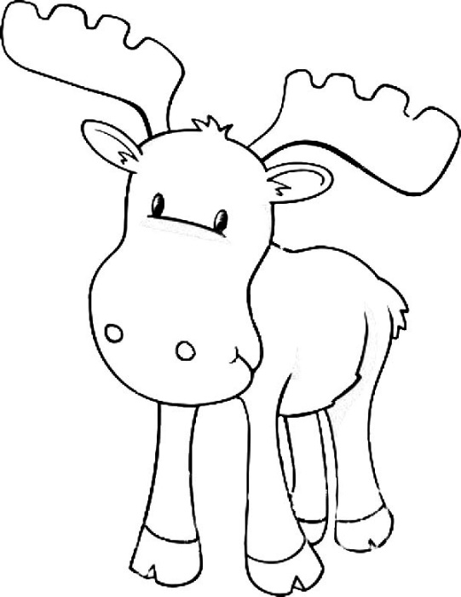
--Spring Break--
Farm
Save the Earth & Rainforest

Important Dates:
6th- Science Night, 6-8pm
7th - Move-a-Thon/Wellness Day
​10th-14th - NO SCHOOL (Holiday/Vacation)
17th - Report Cards sent home
21st - Field Trip (WinterPast Farm)
May 5th - Hunter Heritage, 5:30-8:00pm - Super Fun for All!

Our Classroom Needs: white card stock
LetterLand Day: at Pullen Park Saturday, May 6th, 2017 10am-4pm. Free admission into park. Rides $1 Information can be found on http://wakeupandread.org/events/letterland/
Online Resources: Big Universe and Epic Books are great resources for reading child at home! If you are using either of these resources, we’d love to hear your feedback to help us make choices for continuing with them next year. Please send an email with your thoughts.
Chaperones Needed: We are in need of chaperones for our WinterPast Field Trip on April, 21st from about 10:00am to about 12:30pm. Please email me if you can help celler@wcpss.net
Mark Your Calendars: Our final Student Led Conferences will be held on June 2nd at 2:45. As at past student led conferences, this will be a time for you to meet with your child to set goals based on their digital portfolios. Please plan to send at least one adult to work with your child.
Donor’s Choose: Our Seesaw sound booth project was funded! A great big thank you to all who shared and donated to our project. The best way for you to help us to get projects funded is to spread the word! We appreciate your help.
Math:
Addition & Subtraction within 10: Represent addition and subtraction with objects, fingers, mental images, drawings, sounds (e.g., claps), acting out situations, verbal explanations, expressions, or equations. Solve addition and subtraction word problems, and add and subtract within 10, e.g., by using objects or drawings to represent the problem. Decompose numbers less than or equal to 10 into pairs in more than one way, e.g., by using objects or drawings, and record each decomposition by a drawing or equation (e.g., 5 = 2 + 3 and 5 = 4 + 1). For any number from 1 to 9, find the number that makes 10 when added to the given number, e.g., by using objects or drawings, and record the answer with a drawing or equation. Fluently add and subtract within 10.
Literacy:
Unit 6: In Our Community, We Learn About Ourselves and Our World by Reading for Information. In this unit students will discover more about the world around them through information books. Key Ideas and Details - identify the main topic and retell key details of a text, describe the connection between two individuals, events, ideas, or pieces of information in a text, name the author and illustrator of a text and define the role of each in presenting the ideas or information in a text, describe the relationship between illustrations and the text in which they appear (e.g., what person, place, thing or idea in the text and illustration depict), identify the reasons an author gives to support points in the text, and identify basic similarities in and differences between two texts on the same topic (e.g., in illustrations, descriptions, or procedures).
Unit 7: Readers Use All of Their “Tricks and Tools” in their Backpacks When It Comes to Tricky Parts. Readers will learn more strategies to use while they are reading including word solving, cross-checking, self-correcting and making meaning. In this unit students will ask and answer questions about unknown words in a text, compare and contrast the adventures and experiences of characters in familiar stories, identify the reasons an author gives to support points in a text, identify basic similarities in and differences between two texts on the same topic (e.g., in illustrations, descriptions, or procedures.), demonstrate understanding of spoken words, syllables, and sounds (phonemes), count, produce, blend, and segment syllables in spoken words, know and apply grade-level phonics and word analysis skills in decoding words, associate the long and short sounds with common spellings (graphemes) for the five major vowels A,E,I,O,U, recognize and apply vowel patterns (two vowels out walking - feet, boat, magic e - cake, bike. and ask and answer questions in order to seek help, get information, or clarify something that is not understood.
Writing:
Unit 7: Informational Writing - All About Books
Use a combination of drawing, dictating, and writing to compose informative/explanatory texts in which they name what they are writing about and supply some information about the topic. Use a combination of drawing, dictating, and writing to narrate a single event or loosely linked events, tell about the events in the order in which they occurred, and provide a reaction to what happened. Participate in shared research and writing projects.
Word Wall Words: Please continue to work with your child on our High Frequency Word List. The words we have learned thus far are expected to be read and spelled correctly. Students are expected to know 50 of these (See “reading resources” tab on class website for a list of the words to practice at home).
Science: Animals Two by Two. Compare and contrast animals, compare characteristics of living and nonliving things in terms of structure, growth, changes, movement, basic needs, and understand the position and motions of objects and organisms observed in the environment.

